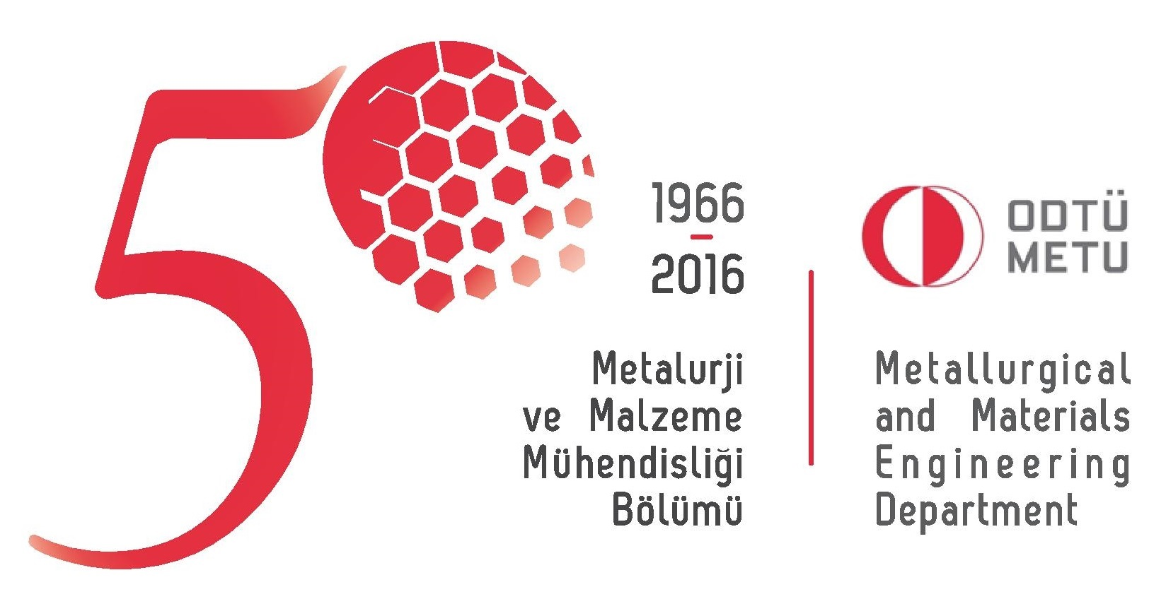

Middle East Technical University
Department of Metallurgical and Materials Engineering

Dear Applicant,
Please read the following instructions for the preparation of your “letter of intent”.
In your letter of intent clearly indicate:
- Your purpose in graduate study (i.e. why do you plan to pursue a graduate degree? What is your career goal?)
- The area you want to specialize in (It is fine to mention a faculty name here)
- Your undergraduate research experiences, if any
- Publication record, if any (particularly for Ph.D. applicants)
- Attended conferences, certificate programs, if any
- Technical and/or academic capabilities (i.e. materials characterization, production/fabrication techniques, software)
- Personal history
- Plans after graduation

